

Ninong & Ninang

Genilda C. Lumimbay
Algen R. Banuelos
Andrea Labiran
Ellonor M. Andres
Milagrina O. Tegero
Marjorie C. Mailed

Rowino Andres
Kert Galinato
Romeo Concon
James Jefferson Dela Cruz
Ronie Cusong
Remlin L. Rojas

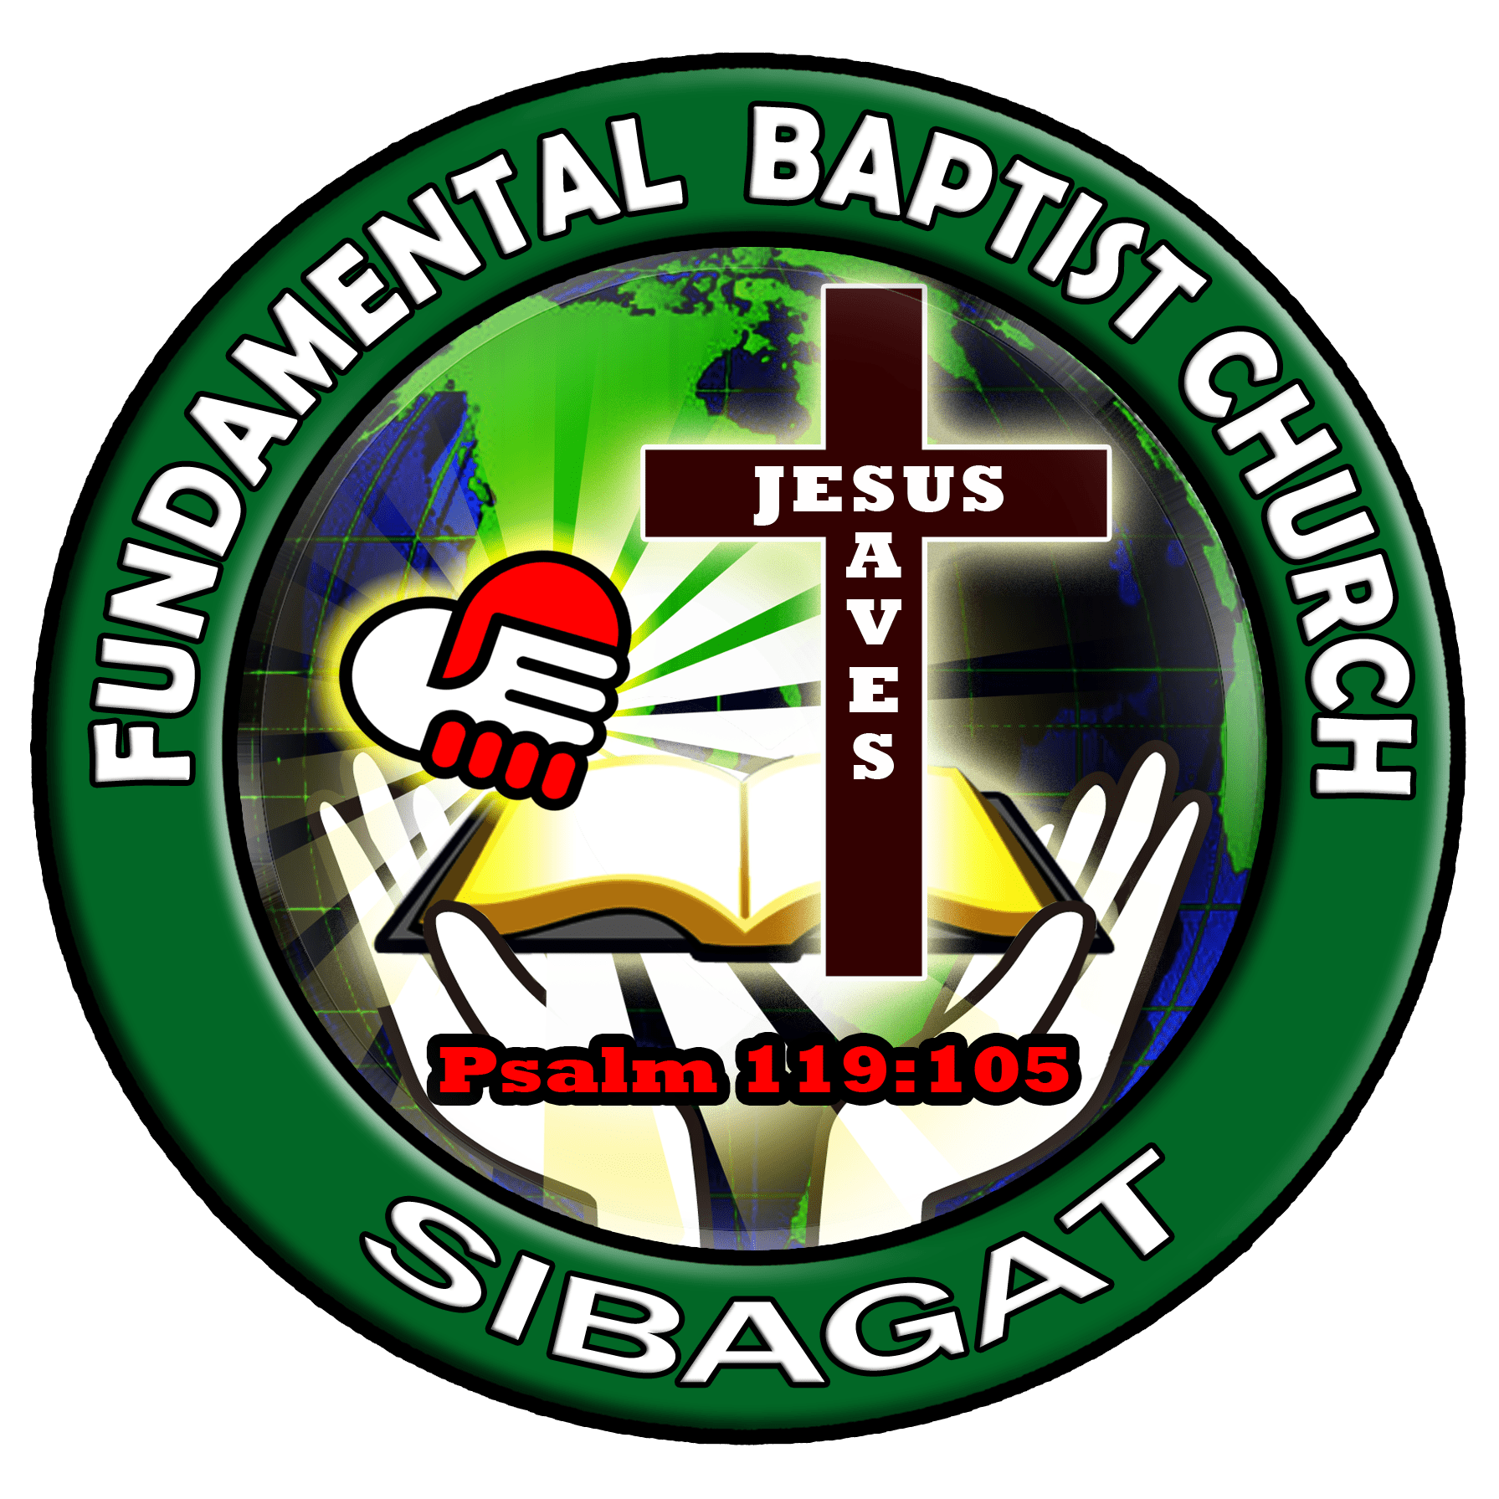
"Children are a heritage from the Lord, offspring a reward from him.".
Psalm 127:3

